**Project Name: XXXXXXXXXXXXXX**

**Purpose Of This Project:**

Traffic jam is a phenomenon that occurs when the flow of vehicles on a road becomes slow or comes to a complete stop due to an excessive number of vehicles or other reasons such as construction or accidents. This can lead to increased travel times and frustration for drivers, as well as increased air pollution and fuel consumption.

Road accidents are a major cause of death and injury worldwide. They are caused by a variety of factors, including driver behavior, road design, and vehicle defects. Common causes of accidents include distracted driving, speeding, and driving under the influence of drugs or alcohol. Poor road design and inadequate traffic control can also contribute to accidents.

Both traffic jam and road accident are a major problem for public and government. They cause loss of lives, injury, damage to property, loss of productivity and increase the cost of healthcare. They also have a negative impact on the environment and on overall quality of life. Governments and private organizations are constantly looking for ways to reduce traffic congestion and improve road safety to mitigate these problems.

To avoid this major events we’ve prepared this model. Which will allow to bring accidental rates to almost zero. Basically this a multipurpose project for roads and footpaths. Footpath is being transfered as an expressway which will be located on a flyover at the top of the road. And for the road, It has normally 4 lanes by 2x2 layout but due to emergency it allows to make it 1:3 or 4:0 if needed. It also allows 2 lanes combined single lane for emergency service for ambulance or fire service.

This model is basically designed for crowded and where is a very huge chance of getting accident. To avoid this problem this is an ideal model. This will also reduce traffic jam with modern traffic control system and road control system. No cars will be able to break rules if they want to. All traffics and other system will be controled from a control towen at the center of this model.

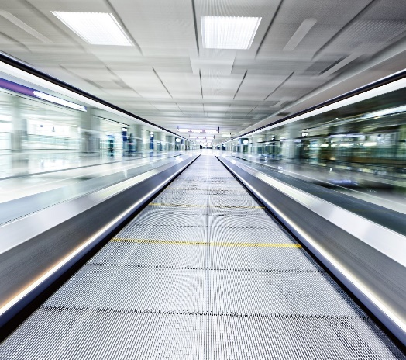

**Details of the elevated expressway:**

This section is exclusively designed for humans to bring themselves and their good to carry autometically from point to point. No one is allowed to enter or exit in expressway from anywhere. They must reach on a specific point to get on board. There is two parts in this section. One is automated and one is manual. By automated section they just have to aboard on the elevated path. And for the manual part people can also walk. Automated belt will take peoples and goods to the bus stopage or the fixed point where people can get on residential area. This will stop the problem of crossing road unnessesaryly to get on any place or get on bus. This will also reduce time to reach stopage. On the still passage you’ll be able to walk or can take rest at fixed benches at some fixed points.

**Details of the road intersection:**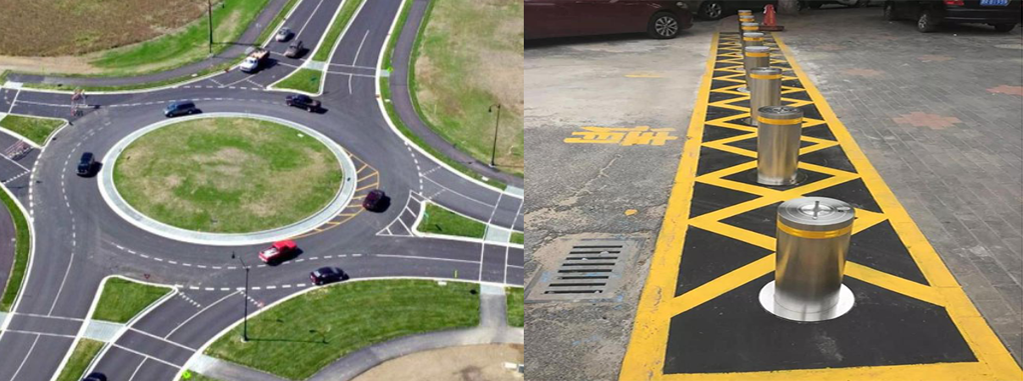

The road section has two different parts. First the intersection and second the divider. For the intersection part, cars will have to go in a right way to change course and bus stopage is in a fixed place and also no road crossing. So, they won’t have to stop the cars to many time, just at the stopage or in any emergency. And for the divider part, It is designed with hydraulic bolards to divide the lanes. Mainly it has normally 4 lanes by 2x2 layout but due to emergency it allows to make it 1:3 or 4:0 if needed. It also allows 2 lanes combined single lane for emergency service for ambulance or fire service. And there will be a light and sound signal before changing lanes layout including a physicial barrier before the emergency lane get aligned.

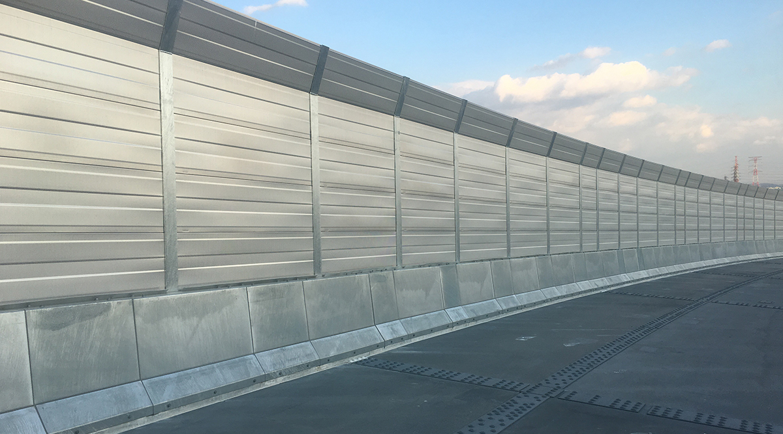

The road also has a noiseproof glass at both sides of the road to reduce noise. This will reduce the noise so that the sound don’t make problems to residential area’s peoples.